Open Systems Interconnection (OSI) Model

* *OSI (Osi Systems Interconnection) model is a conceptual framework used to understand and standardize the function of a telecommunication or computing system with out a regard to its underlying internal structure and technology. Osi model layers is 7layers.*

**1) PHYSICAL LAYER: The physical layer is first and lowest layer in the OSI model, Allowing data to travel from one place to another place. Without it, no data transmission would be possible, and higher layers the network model couldn’t function .**

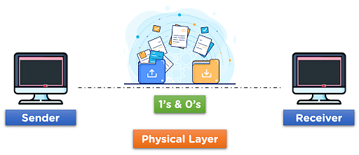

**EX: Hub, Repeater, Modem, Cables are Physical Layer devices.**

**2) APPLICATION LAYER: The Application Layer is topmost layer in OSI model. This layer provides several ways for manipulating the data which actually enables any type of user to access network with ease. This layer also makes a request to its bottom layer.**

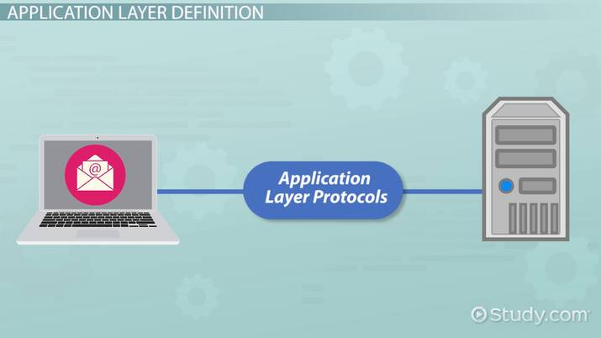

**3) DATA LINK LAYER: The Data Link Layer is the second layer from the bottom in the OSI. The DATA LINK LAYER is responsible for transfer node-node data transfer between two directly connected nodes.**

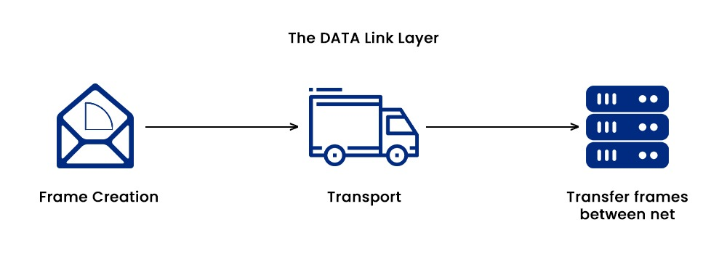

**4) NETWORK LAYER: The network layer works for the transmission of data from one host to the other located in different networks.**

**If also takes care of packet routing i.e. selection of the shortest path to transmit the packet, from the number of routes available.**

**The sender & receiver’s IP address are placed in the header by the network layer.**

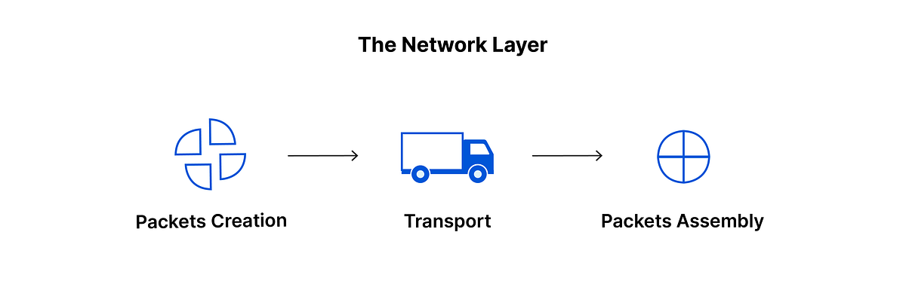

**5) TRANSPORT LAYER: It provides service to the application layer and takes service from the network layer.**

**The transport layer also provides the acknowledgment of he successful data transmission and re-transmits the data if an error is found.**

**It also adds Source and Destination port numbers in its header and forwards the segmented data to the Network Layer.**

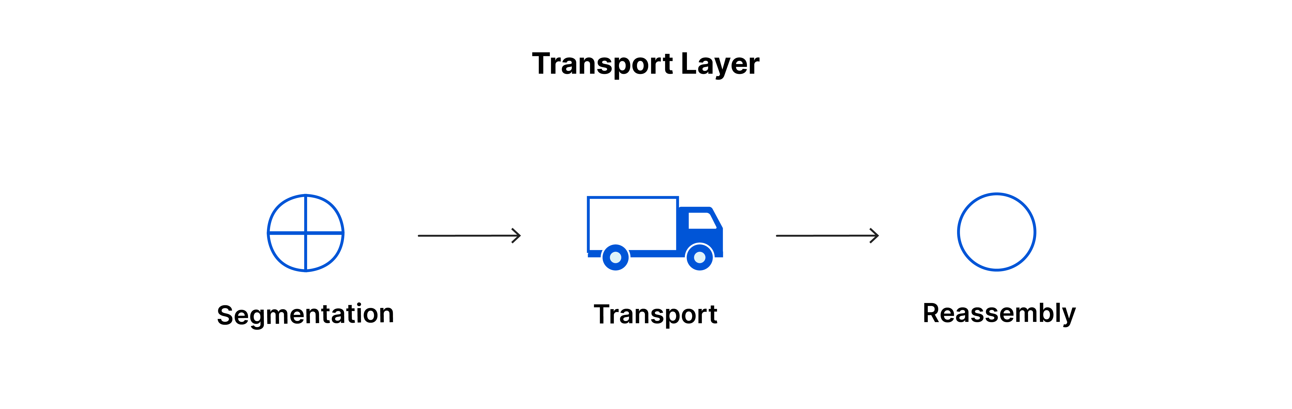

**6) SESSION LAYER: This layer builds the connection between sender and receiver on the internet. And also ensures security.**

**This layer allows the communication between two systems via half duplex .**

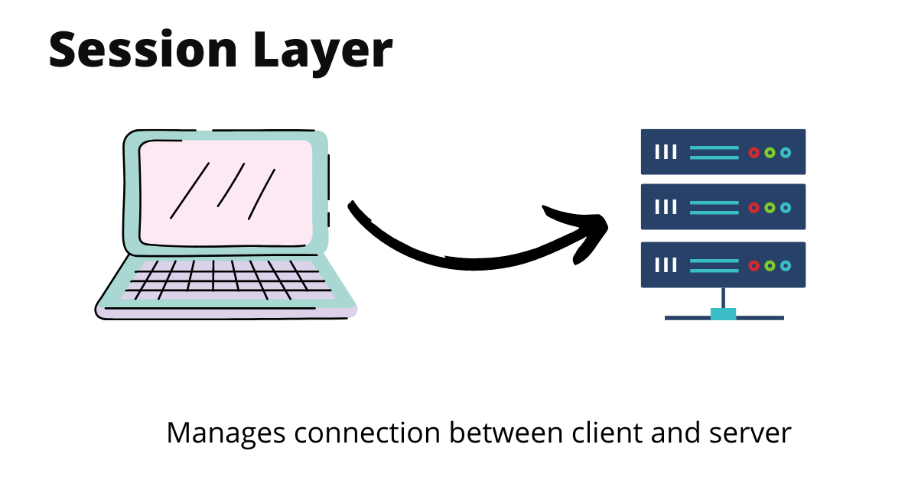

**7) PRESENTATION LAYER: The presentation layer is also called the Translation layer.**

**The data from the application layer is extracted here and manipulated as per the required format to transmit over the network.**

